[2024-2025 Participation Statement]

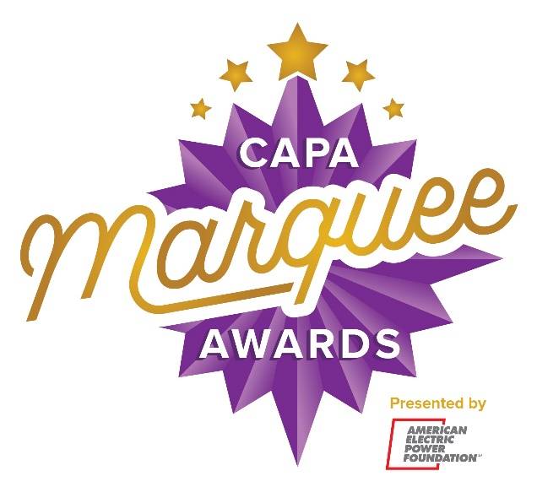

[Insert School Name] is proud to participate in the CAPA Marquee Awards presented by American Electric Power Foundation and produced by the Columbus Association for the Performing Arts! Culminating in a Tony Awards® inspired showcase, the program celebrates and supports musical theatre education in central Ohio high schools. Yearlong learning opportunities include free touring Broadway master classes, workshops with local and regional artists, production feedback from performing arts professionals, discounted tickets to touring Broadway shows when available, performance experiences, and more.

Join us Friday, May 9 at 7:30 p.m. for the 2025 CAPA Marquee Awards Showcase at the Ohio Theatre! Tickets go on sale in the spring. Visit www.capamarqueeawards.com to learn more! Follow us on Instagram at @MarqueeAwards and TikTok at @CAPAColumbus and like us on Facebook at www.facebook.com/capacolumbus.

