[2023-2024 Participation Statement]

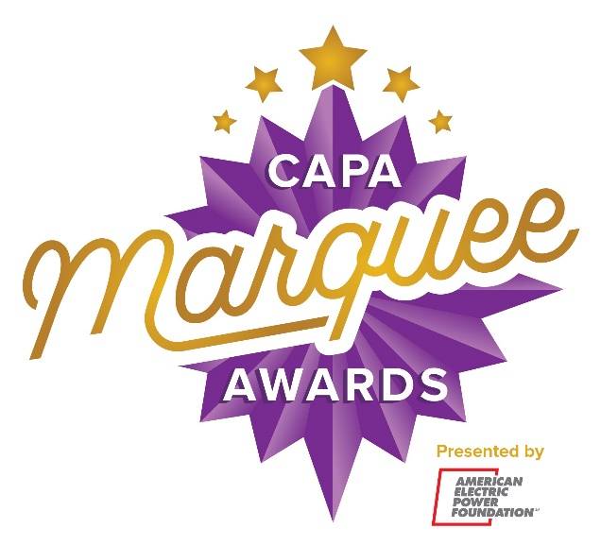

[Insert School Name] is proud to participate in the CAPA Marquee Awards presented by American Electric Power Foundation and produced by the Columbus Association for the Performing Arts! Culminating in a Tony Awards® inspired showcase, the program celebrates and supports musical theatre education in central Ohio high schools. Yearlong learning opportunities include free touring Broadway master classes, workshops with local and regional artists, production feedback from performing arts professionals, discounted tickets to touring Broadway shows when available, performance experiences, and more.

Join us Thursday, June 6 at 7:30 p.m. for the 2024 CAPA Marquee Awards Showcase at the Ohio Theatre! Tickets go on sale in the spring. Visit www.capamarqueeawards.com to learn more! Like us on Facebook at www.facebook.com/capacolumbus and follow us on TikTok at @CAPAColumbus and Instagram at @MarqueeAwards.

